Additional Material:
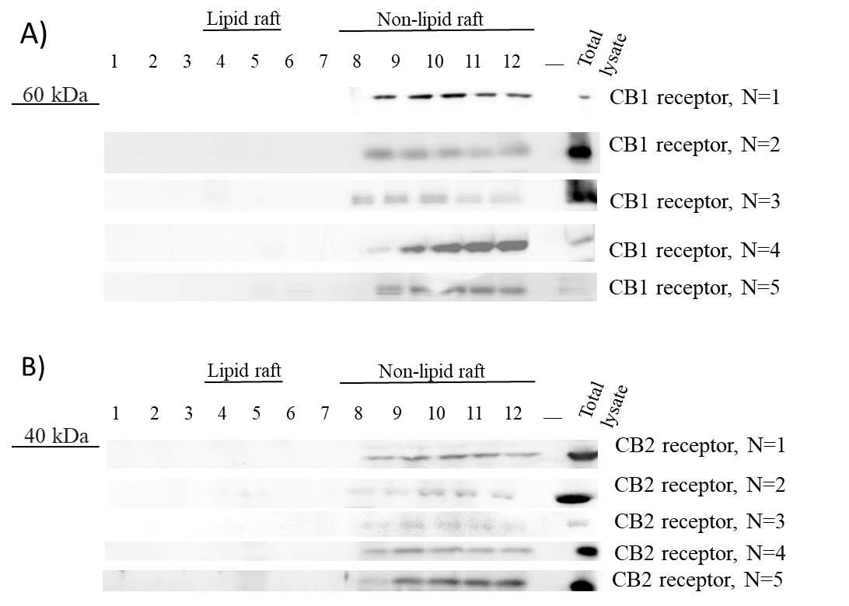
Additional file 1: Figure S1. Raw data for CBRs. CB receptors distribution in the lipid raft and non-raft fractions. A, B) we repeated lipid raft isolation (N=5) to investigate the CB receptors distribution in the plasma membrane of cortical tissues.

