Supplementary materials
Supplementary Figure 1
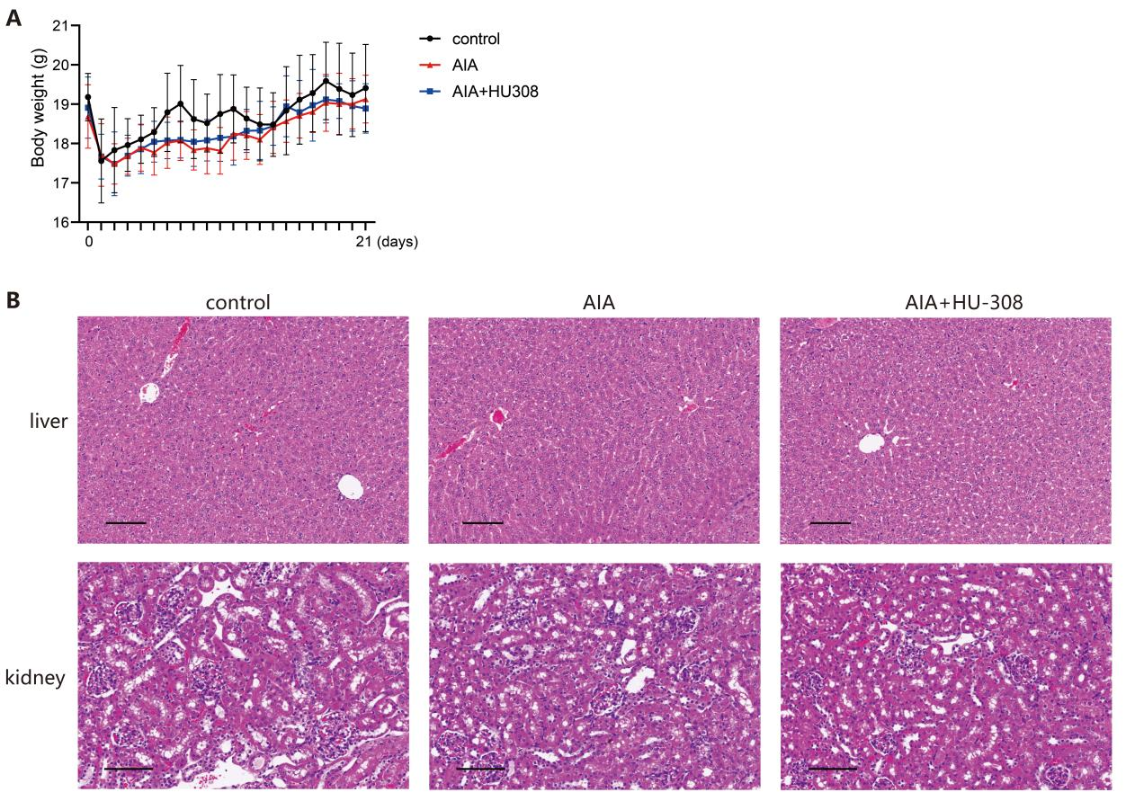
Supplementary Figure 1 HU-308 does not affect mouse body weight or liver and kidney histology. (A) Changes in body weight of mice in different groups during the treatment period with HU-308. The graph shows the average body weight±SEM for each group over the treatment course, indicating no significant weight loss or gain in any of the groups treated with HU-308 compared to not treated. (B) Hematoxylin and eosin (H&E) staining of liver and kidney sections from mice at the end of the HU-308 treatment. Images show representative histology from each group.

Supplementary Figure 2
Supplemental Figure 2 CB2 agonist HU-308 modulates the distribution of immune cell populations in mice with adjuvant-induced arthritis (AIA). (A) Flow cytometry gating strategy for immune cells isolated from the spleen. (B) Summary plot showing frequencies of CD19+, CD8+ CD3+, CD4+ CD3+ and activated CD4+ T cells (CD4+ CD44+ CD62l- ) in the spleen of mice in each group (n=6). Data shown are representative of there independent experiments with similar results. Data are represented as the mean ± SD. *p<0.05 and **p<0.01 by 2-tailed Student’s t test. NS, not significant.

Supplementary Figure 3
Supplemental Figure 3 HU-308 had no impact on Treg cell function. (A) In vitro suppression assay was conducted on mouse nTreg cells, with or without HU-308 stimulation. Mouse nTreg and CD4⁺ T effector cells (responder) were cocultured for 84h at varying ratios 1:1, 1:2, 1:4, 1:8 or 1:16) using anti-CD3/CD28 beads for activation. Proliferation of responder cells was tracked via CTV dye dilution. (B) Proportion of CD4⁺ T effector cell proliferation suppressed by nTreg cells. Data shown are representative of there independent experiments with similar results. Data are represented as the mean ± SD. The significances were measured by 2-tailed Student’s t test. NS, not significant.

Supplementary Table 1: Monoclonal antibodies used for flow cytometry.
Antibody name | Company | Catalog No.
Viability Dye eFluor 780 | eBioscience | 65-0865-14
Anti-Mouse-CD3 Bv605 | BioLegend | 100237
Anti-Mouse-CD4 FITC | eBioscience | 11-0041-85
Anti-Mouse-CD4 PE | eBioscience | 12-0042-85
Anti-Mouse-CD4 PercP-CyTM5.5 | Tonbo bioscience | 65-0042-U100
Anti-Mouse-CD8a Bv510 | BioLegend | 100752
Anti-Mouse-CD19 PE | eBioscience | 12-0193-82
Anti-Mouse-CD45 ef450 | eBioscience | 48-0454-82
Anti-Mouse-CD44 PE | Miltenyi Biotec | 130-102-606
Anti-Mouse-CD62L APC | Tonbo bioscience | 20-0621-U100
Anti-Mouse-CD25 PE | eBioscience | 12-0251-82
Anti-Mouse-IL4 PE | eBioscience | 12-7041-82
Anti-Mouse-IFNγ FITC | Tonbo bioscience | 35-7311-U100
Anti-Mouse-IL-17A ef450 | eBioscience | 48-7177-82
Anti-Mouse-Foxp3 APC | eBioscience | 17-5773-82

Supplementary Table 2: Monoclonal antibodies used for Western blot (WB).
Antibody name | Company | Catalog No.
Phospho-SAPK/JNK (Thr183/Tyr185) Antibody | Cell Signaling Technology | 9251
SAPK/JNK Antibody | Cell Signaling Technology | 9252
Phospho-Akt (Ser473) (D9E) XP® Rabbit mAb | Cell Signaling Technology | 4060
Akt Antibody | Cell Signaling Technology | 9272
Phospho-SMAD2 (Ser465/Ser467) (E8F3R) Rabbit mAb (Biotinylated) | Cell Signaling Technology | 55041
SMAD2 (D43B4) XP® Rabbit mAb | Cell Signaling Technology | 5339
Phospho-Stat5 (Tyr694) (D47E7) XP® Rabbit mAb | Cell Signaling Technology | 4322
Stat5 (D2O6Y) Rabbit mAb | Cell Signaling Technology | 94205
GAPDH Monoclonal Antibody | Proteintech | 60004-1-Ig

Supplementary Table 3: Real-Time Polymerase Chain Reaction (qPCR) Primers.
Gene | Forward (5’-3’) | Reverse (5’-3’)
Actin | TGGAATCCTGTGGCATCCATGAAAC | TAAAACGCAGCTCAGTAACAGTCCG
CB2 | CTCGTACCTGTTCATCAGCAGC | CAGCAGGAAGATAGCGTTGGAG
Foxp3 | GGCCCTTCTCCAGGACAGA | GCTGATCATGGCTGGGTTGT
TGFβ | CTCCCGTGGCTTCTAGTGC | GCCTTAGTTTGGACAGGATCTG
CD25 | GCGTTGCTTAGGAAACTCCTGG | GCATAGACTGTGTTGGCTTCTGC
IL2 | GCGGCATGTTCTGGATTTGACTC | CCACCACAGTTGCTGACTCATC
IL10 | GCTCTTACTGACTGGCATGAG | CGCAGCTCTAGGAGCATGTG
GzmB | CAGGAGAAGACCCAGCAAGTCA | CTCACAGCTCTAGTCCTCTTGG
IL17A | TCCAGAAGGCCCTCAGACTA | CTCGACCCTGAAAGTGAAGG
IL17F | CCCAGGGTCAGGAAGACA | CCGAAGGACCAGGATTTCT
Ror-γt | AACCAGGCATCCTGAACTTG | CGTAGAAGGTCCTCCAGTCG

