Supplementary material

Supplementary 1: Based on OPM database coordinates, we generated this equation to embed the complexes into the bilayer membrane.

(((((((((((((((((((((((res.num 7-31) AND (( res.sec helix ) )) AND ((chain.name B))) OR (res.num 34- 59)) AND (( res.sec helix ) )) AND ((chain.name A))) OR (res.num 69- 93)) AND (( res.sec helix ) )) AND ((chain.name A))) OR (res.num 107- 130)) AND (( res.sec helix ) )) AND ((chain.name A))) OR (res.num 148- 170)) AND (( res.sec helix ) )) AND ((chain.name A))) OR (res.num 190- 213)) AND (( res.sec helix ) )) AND ((chain.name A))) OR (res.num 246- 266)) AND (( res.sec helix ) )) AND ((chain.name A))) OR (res.num 280- 301)) OR (( res.sec helix ) )) OR ((chain.name A))

Supplementary 2: Best ranking poses after IFD between CB2-HER2 complex and A) THC, and B) Nabilone. GREEN represents the hydrophobic interactions, CYAN represents polar interactions, and the PURPLE arrow represents the hydrogen bonds.

Supplementary 3: Table of averages of RMSF values after the focused analysis, where CB2 and HER2 RMSF values were split into 2 sets and interpreted separately.

 | No Ligand |  | THC |  | Nabilone
 | Mean | SD | Mean | SD | Mean | SD
CB2 | 1.28 | 1.23 | 1.49 | 1.30 | 1.23 | 1.05
HER2 | 2.08 | 0.83 | 2.13 | 1.08 | 2.56 | 1.38

Supplementary 4: Protein-Ligand interactions between CB2-HER2 and THC throughout the simulation time.

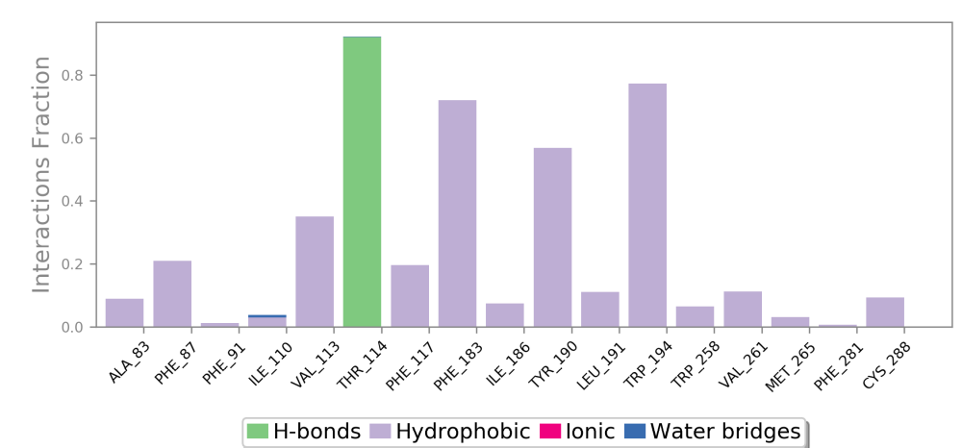

Supplementary 5: Protein-Ligand interactions between CB2-HER2 and Nabilone throughout the simulation time.

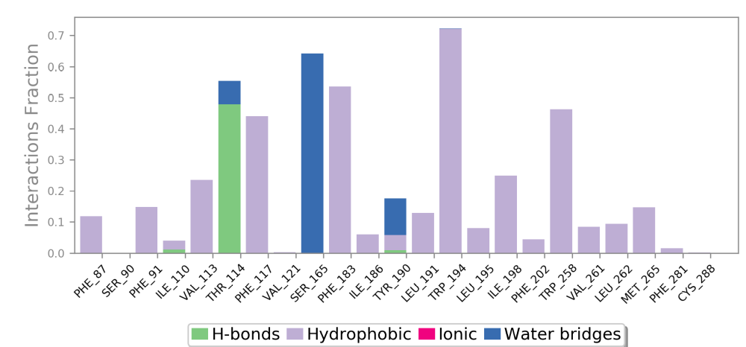

Supplementary 6: Structural superimposition of THC-bound complex (Green), Nabilone-bound complex (purple), inactive CB2 PDB 5TZY (blue), and active CB2 PDB 6KPC (Yellow). TM6 is the only structure region displayed for simple visualization.
