Supplementary material
Table S1
Acute effects of distance-related indices
ANOVA | F | p | Cohen’s f
Total distance traveled
Pre-post | 9.31 | .009 | .40
Pre-post × Group | 2.09 | .17 | .13
Context | 0.06 | .80 | .005
Context × Group | 3.81 | .07 | .21
Pre-post × Context | 2.97 | .10 | .17
Pre-post × Context × Group | 6.75 | .02 | .32
Group | 0.25 | .61 | .01
Distance traveled on the periphery
Pre-post | 7.86 | .01 | .36
Pre-post × Group | 1.59 | .22 | .10
Context | 0.03 | .86 | .00
Context × Group | 1.48 | .24 | .09
Pre-post × Context | 1.54 | .23 | .10
Pre-post × Context × Group | 5.26 | .03 | .27
Group | 0.11 | .74 | .008
Distance traveled in the center
Pre-post | 3.23 | .09 | .18
Pre-post × Group | 2.20 | .16 | .13
Context | 2.21e-4 | .98 | .000
Context × Group | 9.49 | .008 | .40
Pre-post × Context | 6.01 | .02 | .30
Pre-post × Context × Group | 2.61 | .12 | .157
Group | 0.65 | .43 | .045
Note. ANOVA F-test, p-value and Cohen’s f of each analysis performed (main effects and interactions) are shown. Significant results are highlighted in bold.

Table S2
Acute effects of time-related indices
ANOVA | F | p | Cohen’s f
Time in movement
Pre-post | 10.97 | .005 | .43
Pre-post × Group | 2.13 | .16 | .13
Context | 0.002 | .95 | .00
Context × Group | 6.87 | .02 | .32
Pre-post × Context | 4.23 | .05 | .23
Pre-post × Context × Group | 3.95 | .06 | .22
Group | 0.38 | .54 | .02
Time in immobility
Pre-post | 10.97 | .005 | .43
Pre-post × Group | 2.13 | .16 | .13
Context | 0.002 | .95 | .000
Context × Group | 6.87 | .02 | .32
Pre-post × Context | 4.23 | .05 | .23
Pre-post × Context × Group | 3.95 | .06 | .22
Group | 0.38 | .54 | .02
Time in the center
Pre-post | 0.99 | .33 | .06
Pre-post × Group | 2.13 | .16 | .13
Context | 0.005 | .94 | .000
Context × Group | 7.49 | .01 | .34
Pre-post × Context | 3.25 | .09 | .18
Pre-post × Context × Group | 3.93 | .06 | .21
Group | 0.17 | .68 | .01
Time on the periphery
Pre-post | 4.54 | .05 | .24
Pre-post × Group | 1.48 | .24 | .09
Context | 0.009 | .92 | .001
Context × Group | 3.22 | .09 | .18
Pre-post × Context | 0.83 | .37 | .05
Pre-post × Context × Group | 2.09 | .17 | .13
Group | 0.32 | .57 | .02
Note. ANOVA F-test, p-value and Cohen’s f of each analysis performed (main effects and interactions) are shown. Significant results are highlighted in bold.

Table S3
Acute effects of non-exploratory activities
ANOVA | F | p | Cohen’s f
Grooming
Pre-post | 11.86 | .004 | .45
Pre-post × Group | 2.79 | .11 | .16
Context | 0.05 | .81 | .00
Context × Group | 4.72 | .04 | .25
Pre-post × Context | 3.92 | .06 | .21
Pre-post × Context × Group | 4.90 | .04 | .26
Group | 0.05 | .81 | .004
Rearing
Pre-post | 20.55 | < .001 | .59
Pre-post × Group | 0.02 | .88 | .002
Context | 1.70 | .21 | .10
Context × Group | 3.94 | .06 | .22
Pre-post × Context | 0.32 | .57 | .02
Pre-post × Context × Group | 0.09 | .75 | .007
Group | 1.15 | .30 | .07
Scratching
Pre-post | 3.31 | .09 | .19
Pre-post × Group | 0.36 | .55 | .02
Context | 0.36 | .55 | .02
Context × Group | 3.31 | .09 | .19
Pre-post × Context | 0.36 | .55 | .02
Pre-post × Context × Group | 3.31 | .09 | .19
Group | 0.36 | .55 | .02
Note. ANOVA F-test, p-value and Cohen’s f of each analysis performed (main effects and interactions) are shown. Significant results are highlighted in bold.

Table S4
Chronic tolerance of distance-related indices
ANOVA | F | p | Cohen’s f
Total distance traveled
Measurements | 4.11 | .005 | .22
Measurements × Group | 2.39 | .06 | .04
Context | 0.64 | .43 | .04
Context × Group | 0.60 | .45 | .04
Context × Measurements | 1.17 | .33 | .07
Context × Measurement × Group | 2.71 | .03 | .16
Group | 0.18 | .67 | .01
Distance traveled on the periphery
Measurements | 1.66 | .17 | .10
Measurements × Group | 2.36 | .06 | .14
Context | 1.85 | .19 | .11
Context × Group | 2.07 | .17 | .12
Context × Measurements | 1.30 | .28 | .08
Context × Measurement × Group | 3.16 | .02 | .18
Group | 0.81 | .38 | .05
Distance traveled in the center
Measurements | 7.09 | < .001 | .33
Measurements × Group | 3.40 | .01 | .19
Context | 0.31 | .58 | .02
Context × Group | 0.07 | .78 | .006
Context × Measurements | 2.44 | .05 | .14
Context × Measurement × Group | 2.07 | .09 | .12
Group | 0.43 | .51 | .03
Note. ANOVA F-test, p-value and Cohen’s f of each analysis performed (main effects and interactions) are shown. Significant results are highlighted in bold.

Tabla S5
Chronic tolerance of time-related indices
ANOVA | F | p | Cohen’s f
Time in movement
Measurements | 4.41 | .004 | .23
Measurements × Group | 4.88 | .002 | .25
Context | 1.30 | .27 | .08
Context × Group | 2.83 | .11 | .16
Context × Measurements | 2.42 | .05 | .14
Context × Measurement × Group | 3.26 | .01 | .18
Group | 0.96 | .34 | .06
Time in immobility
Measurements | 4.41 | .004 | .24
Measurements × Group | 4.88 | .002 | .25
Context | 1.30 | .27 | .08
Context × Group | 2.83 | .11 | .16
Context × Measurements | 2.42 | .05 | .14
Context × Measurement × Group | 3.26 | .01 | .18
Group | 0.96 | .34 | .06
Time in the center
Measurements | 9.46 | < .001 | .40
Measurements × Group | 4.01 | .006 | .22
Context | 2.27 | .15 | .14
Context × Group | 1.22 | .28 | .08
Context × Measurements | 1.23 | .30 | .08
Context × Measurement × Group | 1.78 | .14 | .11
Group | 1.49 | .24 | .09
Time on the periphery
Measurements | 11.37 | < .001 | .44
Measurements × Group | 3.19 | .02 | .18
Context | 1.38 | .25 | .09
Context × Group | 0.59 | .45 | .04
Context × Measurements | 1.04 | .39 | .07
Context × Measurement × Group | 1.82 | .13 | .11
Group | 0.76 | .39 | .05
Note. ANOVA F-test, p-value and Cohen’s f of each analysis performed (main effects and interactions) are shown. Significant results are highlighted in bold.

Table S6
Chronic tolerance of non-exploratory activities
ANOVA | F | p | Cohen’s f
Grooming
Measurements | 0.60 | .66 | .04
Measurements × Group | 0.56 | .68 | .03
Context | 8.56 | .01 | .37
Context × Group | 6.29 | .02 | .31
Context × Measurements | 0.83 | .50 | .05
Context × Measurement × Group | 1.71 | .16 | .10
Group | 14.30 | .002 | .50
Rearing
Measurements | 4.15 | .005 | .22
Measurements × Group | 2.37 | .06 | .14
Context | 22.29 | < .001 | .61
Context × Group | 33.89 | < .001 | .70
Context × Measurements | 2.35 | .06 | .14
Context × Measurement × Group | 1.23 | .30 | .08
Group | 11.00 | .005 | .44
Scratching
Measurements | 0.11 | .97 | .008
Measurements × Group | 0.54 | .70 | .03
Context | 20.33 | < .001 | .59
Context × Group | 0.02 | .87 | .002
Context × Measurements | 2.01 | .10 | .12
Context × Measurement × Group | 0.43 | .78 | .03
Group | 0.09 | .76 | .006
Note. ANOVA F-test, p-value and Cohen’s f of each analysis performed (main effects and interactions) are shown. Significant results are highlighted in bold.

Table S7
Contextual specificity of tolerance of distance-related indices
ANOVA | F | p | Cohen’s f
Total distance traveled
Context | 0.21 | .65 | .01
Context × Group | 0.01 | .91 | .001
Group | 10.10 | .007 | .41
Distance traveled on the periphery
Context | 0.79 | .38 | .05
Context × Group | 0.57 | .46 | .03
Group | 2.84 | .11 | .16
Distance traveled in the center
Context | 3.29 | .09 | .19
Context × Group | 0.63 | .44 | .04
Group | 9.18 | .009 | .39
Note. ANOVA F-test, p-value and Cohen’s f of each analysis performed (main effects and interactions) are shown. Significant results are highlighted in bold.

Table S8
Contextual specificity of tolerance of time-related indices
ANOVA | F | p | Cohen’s f
Time in movement
Context | 2.06 | .17 | .12
Context × Group | 0.001 | .97 | .000
Group | 11.00 | .005 | .44
Time in immobility
Context | 2.06 | .17 | .12
Context × Group | 0.001 | .97 | .000
Group | 11.00 | .005 | .44
Time in the center
Context | 4.70 | .04 | .25
Context × Group | 0.77 | .39 | .05
Group | 3.10 | .10 | .18
Time on the periphery
Context | 4.00 | .06 | .22
Context × Group | 0.90 | .35 | .06
Group | 3.74 | .07 | .21
Note. ANOVA F-test, p-value and Cohen’s f of each analysis performed (main effects and interactions) are shown. Significant results are highlighted in bold.

Table S9
Contextual specificity of tolerance of non-exploratory activities
ANOVA | F | p | Cohen’s f
Grooming
Context | 5.33 | .03 | .27
Context × Group | 0.02 | .88 | .002
Group | 4.92 | .04 | .26
Rearing
Context | 0.16 | .68 | .01
Context × Group | 0.02 | .88 | .002
Group | 4.29 | .05 | .23
Scratching
Context | 0.30 | .59 | .02
Context × Group | 0.30 | .59 | .02
Group | 1.34 | .26 | .08
Note. ANOVA F-test, p-value and Cohen’s f of each analysis performed (main effects and interactions) are shown. Significant results are highlighted in bold.

Table S10
Bayesian analysis of the contextual specificity of tolerance in the Drug group
Indicator | BF₁₀ | Error % | Interpretation
Total distance traveled | 0.348 | 0.003 | Anecdotal evidence for H₀
Distance traveled on periphery | 0.338 | 0.003 | Anecdotal evidence for H₀
Distance traveled in the center | 0.419 | 0.006 | Anecdotal evidence for H₀
Time in movement | 0.616 | 0.013 | Anecdotal evidence for H₀
Time in immobility | 0.617 | 0.013 | Anecdotal evidence for H₀
Note. The jsq module of jamovi (The jamovi proyect, 2022) was used to perform a Bayesian Paired Samples T-Test to assess the similarity of the response of the Drug group in the Usual context and in the Novel context. The interpretation of the results followed the guidelines of Rouder et al. (2009). H₀ refers to the null hypothesis.

Table S11
Planned comparisons of the acute effects of total distance traveled
Comparison | F | p | ƞ2p
Pre Drug vs Pre Vehicle (Ctx A) | < 0.01 | .92 | .00
Pre Drug vs Pre Vehicle (Ctx B) | 0.52 | .48 | .03
Post Drug vs Post Vehicle (Ctx B) | 0.41 | .52 | .02
Pre Drug vs Post Drug (Ctx A) | 0.30 | .59 | .02
Pre Vehicle vs Post Vehicle (Ctx A) | 7.10 | .01 | .33
Pre Vehicle vs Post Vehicle (Ctx B) | 8.16 | .01 | .36
Pre Drug vs Post Drug (Ctx B) | 9.36 | .008 | .40
Note. ANOVA F test, p-value, and partial eta squared (ƞ2p) of each nonsignificant planned comparison in the acute effects analysis are shown. Significant results are highlighted in bold.

Table S12
Planned comparisons of the acute effects of distance traveled on the periphery
Comparison | F | p | ƞ2p
Pre Drug vs Pre Vehicle (Ctx A) | 0.04 | .83 | .00
Pre Drug vs Pre Vehicle (Ctx B) | 0.19 | .66 | .01
Post Drug vs Post Vehicle (Ctx B) | 0.20 | .65 | .01
Pre Drug vs Post Drug (Ctx A) | 0.10 | .74 | .00
Pre Vehicle vs Post Vehicle (Ctx A) | 5.72 | .03 | .29
Pre Vehicle vs Post Vehicle (Ctx B) | 7.13 | .01 | .33
Pre Drug vs Post Drug (Ctx B) | 8.47 | .01 | .47
Note. ANOVA F-test, p-value, and partial eta squared (ƞ2p) of each nonsignificant planned comparison in the acute effects analysis are shown. Significant results are highlighted in bold.

Table S13
Planned comparisons of the acute effects of distance traveled in the center
Comparison | F | p | ƞ2p
Pre Drug vs Pre Vehicle (Ctx A) | 0.24 | .62 | .01
Pre Drug vs Pre Vehicle (Ctx B) | 0.82 | .37 | .05
Post Drug vs Post Vehicle (Ctx B) | 0.30 | .59 | .02
Pre Drug vs Post Drug (Ctx A) | 1.36 | .26 | .08
Pre Vehicle vs Post Vehicle (Ctx B) | 1.92 | .18 | .12
Post Vehicle (Ctx A) vs Post Vehicle (Ctx B) | 2.20 | .15 | .13
Note. ANOVA F-test, p-value, and partial eta squared (ƞ2p) of each nonsignificant planned comparison in the acute effects analysis are shown.

Table S14
Planned comparisons of the acute effects of time in movement
Comparison | F | p | ƞ2p
Pre Drug vs Pre Vehicle (Ctx A) | 0.02 | .88 | .00
Pre Drug vs Pre Vehicle (Ctx B) | 0.51 | .48 | .03
Post Drug vs Post Vehicle (Ctx B) | 0.23 | .63 | .01
Pre Drug vs Post Drug (Ctx A) | 0.26 | .61 | .01
Pre Vehicle vs Post Vehicle (Ctx A) | 7.51 | .01 | .34
Pre Vehicle vs Post Vehicle (Ctx B) | 8.11 | .01 | .36
Pre Drug vs Post Drug (Ctx B) | 7.36 | .01 | .34
Note. ANOVA F-test, p-value, and partial eta squared (ƞ2p) of each nonsignificant planned comparison in the acute effects analysis are shown. Significant results are highlighted in bold.

Table S15
Planned comparisons of the acute effects of time in immobility
Comparison | F | p | ƞ2p
Pre Drug vs Pre Vehicle (Ctx A) | 0.02 | .88 | .00
Pre Drug vs Pre Vehicle (Ctx B) | 0.51 | .48 | .03
Post Drug vs Post Vehicle (Ctx B) | 0.23 | .63 | .01
Pre Drug vs Post Drug (Ctx A) | 0.26 | .61 | .01
Pre Vehicle vs Post Vehicle (Ctx A) | 7.51 | .01 | .34
Pre Vehicle vs Post Vehicle (Ctx B) | 8.11 | .01 | .36
Pre Drug vs Post Drug (Ctx B) | 7.36 | .01 | .34
Note. ANOVA F-test, p-value, and partial eta squared (ƞ2p) of each nonsignificant planned comparison in the acute effects analysis are shown. Significant results are highlighted in bold.

Table S16
Planned comparisons of the acute effects of time in center
Comparison | F | p | ƞ2p
Pre Drug vs Pre Vehicle (Ctx A) | < 0.01 | .98 | .00
Pre Drug vs Pre Vehicle (Ctx B) | 0.73 | .40 | .04
Post Drug vs Post Vehicle | 0.25 | .62 | .01
Pre Drug vs Post Drug (Ctx A) | 2.26 | .15 | .13
Pre Vehicle vs Post Vehicle (Ctx A) | 2.12 | .16 | .13
Pre Drug vs Post Drug (Ctx B) | 1.31 | .27 | .08
Pre Vehicle vs Post Vehicle (Ctx B) | 2.47 | .13 | .14
Post Drug vs Post Vehicle (Ctx B) | 0.25 | .62 | .01
Note. ANOVA F-test, p-value, and partial eta squared (ƞ2p) of each nonsignificant planned comparison in the acute effects analysis are shown. Significant results are highlighted in bold.

Table S17
Planned comparisons of the acute effects of grooming
Comparison | F | p | ƞ2p
Pre Drug vs Pre Vehicle (Ctx A) | 0.23 | .63 | .01
Pre Drug vs Pre Vehicle (Ctx B) | 1.06 | .31 | .07
Post Drug vs Post Vehicle (Ctx A) | 2.15 | .16 | .13
Pre Vehicle vs Post Vehicle (Ctx B) | 0.89 | .35 | .05
Pre Drug vs Post Drug (Ctx B) | 1.30 | .27 | .08
Pre Vehicle vs Post Vehicle (Ctx B) | 2.93 | .10 | .17
Note. ANOVA F-test, p-value, and partial eta squared (ƞ2p) of each nonsignificant planned comparison in the acute effects analysis are shown.

Table S18
Planned comparisons of chronic tolerance of total distance traveled
Comparison | F | p | ƞ2p
Drug 1 vs Vehicle 1 (Ctx B) | 0.02 | .88 | .00
Drug 5 vs Vehicle 5 (Ctx B) | 2.09 | .17 | .12
Drug 2 vs Vehicle 2 (Ctx A) | 0.03 | .85 | .00
Note. ANOVA F-test, p-value, and partial eta squared (ƞ2p) of each nonsignificant planned comparison in the chronic tolerance analysis are shown.

Table S19
Planned comparisons of chronic tolerance of distance traveled on the periphery
Comparison | F | p | ƞ2p
Drug 1 vs Vehicle 1 (Ctx B) | 0.02 | .86 | .00
Drug 5 vs Vehicle 5 (Ctx B) | 1.99 | .17 | .12
Drug 2 vs Vehicle 2 (Ctx A) | 0.89 | .36 | .05
Note. ANOVA F-test, p-value, and partial eta squared (ƞ2p) of each nonsignificant planned comparison in the chronic tolerance analysis are shown.

Table S20
Planned comparisons of chronic tolerance of distance traveled in the center
Comparison | F | p | ƞ2p
Drug 1 vs Vehicle 1 (Ctx A) | 3.26 | .09 | .18
Drug 1 vs Vehicle 1 (Ctx B) | 0.22 | .64 | .01
Vehicle 1 (Ctx A) vs Vehicle 1 (Ctx B) | 0.35 | .56 | .02
Vehicle 5 (Ctx A) vs Vehicle 5 (Ctx B) | 0.06 | .80 | .00
Drug 5 vs Vehicle 5 (Ctx A) | 3.18 | .09 | .18
Drug 5 vs Vehicle 5 (Ctx B) | 0.42 | .52 | .02
Drug 2 (Ctx A) vs Drug 2 (Ctx B) | 4.14 | .06 | .22
Note. ANOVA F-test, p-value, and partial eta squared (ƞ2p) of each nonsignificant planned comparison in the chronic tolerance analysis are shown.

Table S21
Planned comparisons of the chronic tolerance of time-related indices
Comparison | F | p | ƞ2p
Time in movement
Drug 1 vs Vehicle 1 (Ctx B) | < 0.01 | .92 | .00
Time in immobility
Drug 1 vs Vehicle 1 (Ctx B) | < 0.01 | .92 | .00
Note. ANOVA-F test, p-value, and partial eta squared (ƞ2p) of each nonsignificant planned comparison in the chronic tolerance analysis are shown.

Figure S1
Pre- and post-vaporization scores in total distance traveled during chronic tolerance
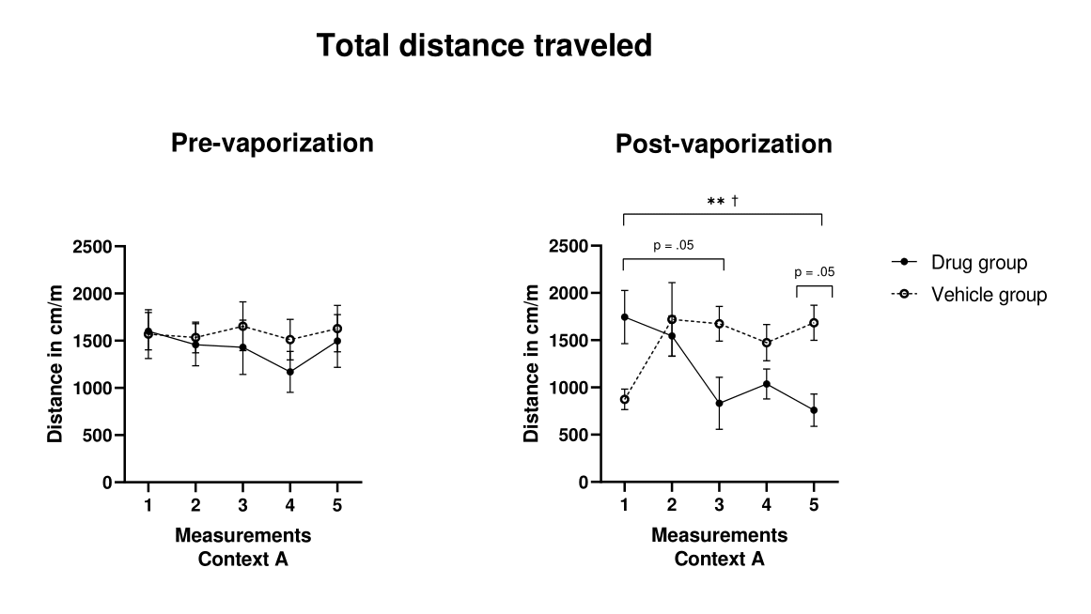
Note. Distance traveled in cm/m for both groups is shown for all pre-vaporization (left) and post-vaporization (right) chronic tolerance measurements in Context A (i.e., where the Drug group received cannabis). The bars represent the standard error of the mean. † indicates within-group differences in the Vehicle group. Non-significant comparisons are labeled with their specific p-values. The number of symbols reflects the level of statistical significance (e.g., †p < .05, ††p < .01, †††p < .001).
Post-hoc analyses were performed to evaluate differences between groups and measurements. During pre-vaporization no significant differences were found (all p-values > .05). On the other hand, in the post-vaporization measurement, differences were found between measurement 1 and measurement 5 of the Drug group (p = .001, MD = 985.458, SE = 165.401), between measurement 1 and 5 of the Vehicle group (p = .006, MD = -809.628, SE = 165.401). In addition, comparisons close to significance were found between measurement 5 of the Drug group and measurement 5 of the Vehicle group (p = .056, MD = -924.706, SE = 253.050) and between measurement 1 and measurement 3 of the Drug group (p = .051, MD = 912.437, SE = 246.472). The data obtained support the development of chronic tolerance in this indicator.

Figure S2
Pre- and post-vaporization scores in distance traveled on the periphery during chronic tolerance
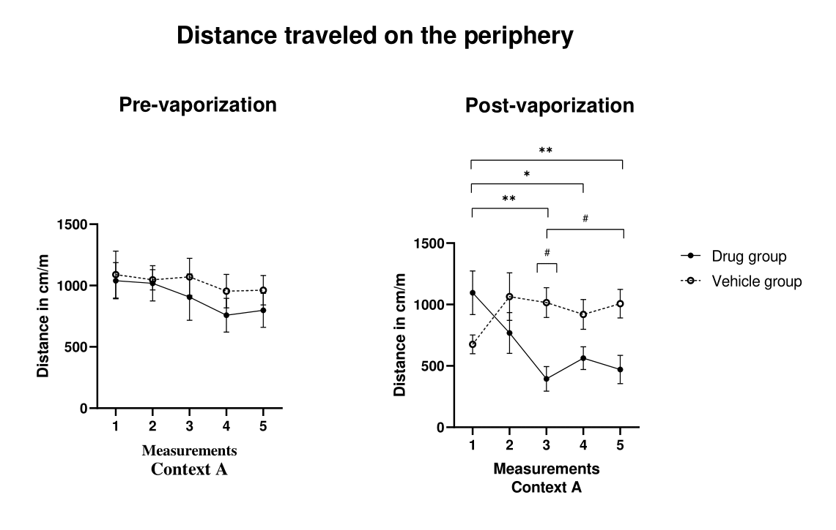
Note. Distance traveled in cm/m for both groups is shown for all pre-vaporization (left) and post-vaporization (right) chronic tolerance measurements in Context A (i.e., where the Drug group received cannabis). The bars represent the standard error of the mean. * indicates within-group differences in the Drug group, and # indicates between-group differences between the Drug and Vehicle groups. The number of symbols reflects the level of statistical significance (e.g., *p < .05, **p < .01, ***p < .001).
Post-hoc analyses were performed to evaluate differences between groups and measurements. During pre-vaporization no significant differences were found (all p-values > .05). On the other hand, during post-vaporization differences were found between measurement 1 and measurement 3 of the Drug group (p = .005, MD = 700.816, SE = 139.134), between measurement 1 and measurement 4 of the Drug group (p = .017, MD = 532.440, SE = 122.937), between measurement 1 and measurement 5 of the Drug group (p = .002, MD = 624.675, SE = 113.153), between measurement 3 of the Drug group and measurement 3 of the Vehicle group (p = .033, MD = -620.770, SE = 157.028) and between measurement 3 of the Drug group and measurement 5 of the Vehicle group (p = .042, MD = -612.432, SE = 160.341).

Figure S3
Pre- and post-vaporization scores in distance traveled in the center during chronic tolerance
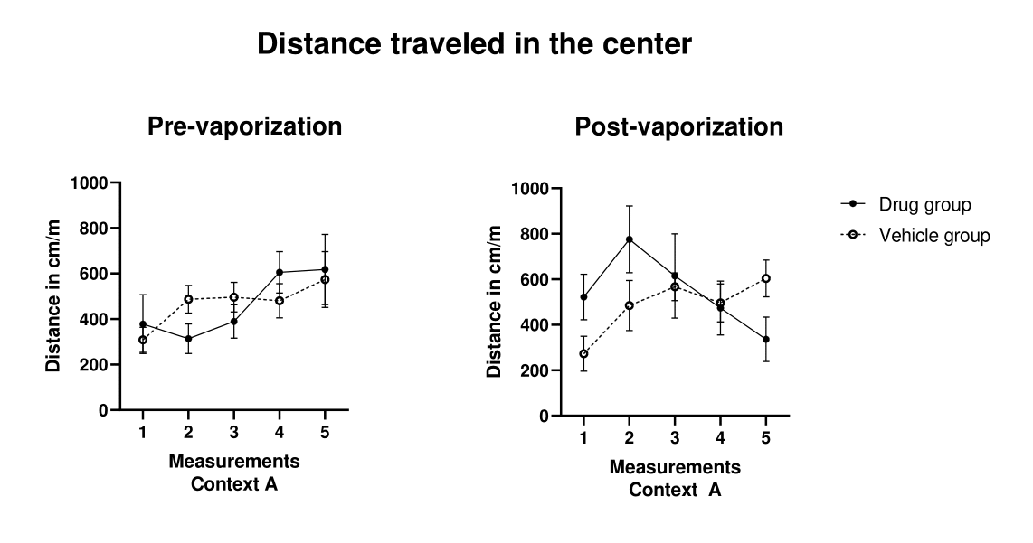
Note. Distance traveled in cm/m for both groups is shown for all pre-vaporization (left) and post-vaporization (right) chronic tolerance measurements in Context A (i.e., where the Drug group received cannabis). The bars represent the standard error of the mean.
Post-hoc analyses were performed to evaluate differences between groups and measurements. During pre-vaporization and post-vaporization no significant differences were found (all p-values > .05).

Figure S4
Pre- and post-vaporization scores in time in movement during chronic tolerance
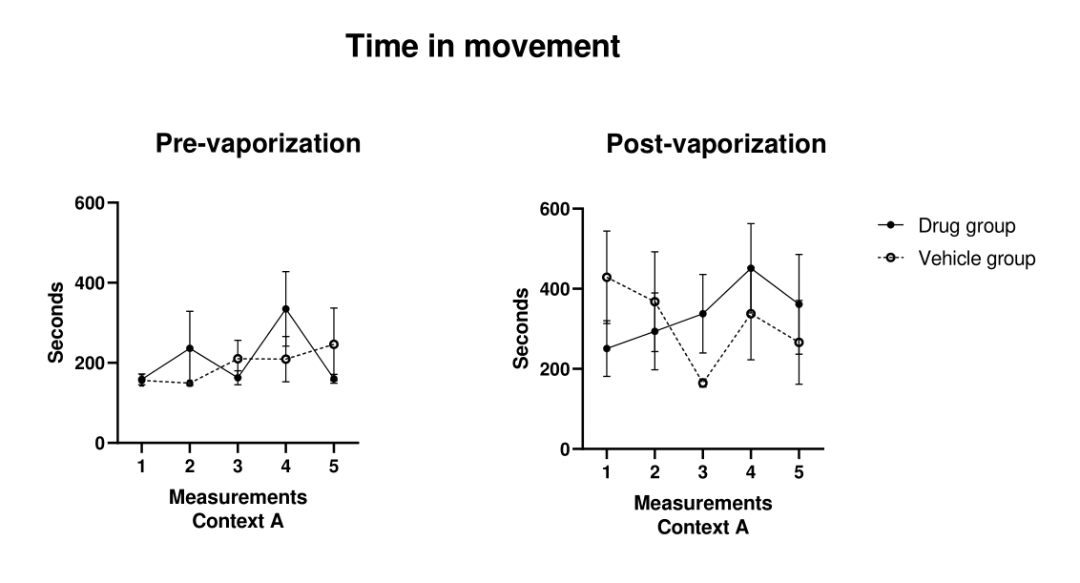
Note. Shown are the movement seconds of both groups for all pre-vaporization (left) and post-vaporization (right) chronic tolerance measurements in Context A (i.e., where the Drug group received cannabis). The bars represent the standard error of the mean.
Post-hoc analyses were performed to evaluate differences between groups and measurements. During pre-vaporization and post-vaporization no significant differences were found (all p-values > .05).

Figure S5
Pre- and post-vaporization scores in time in immobility during chronic tolerance
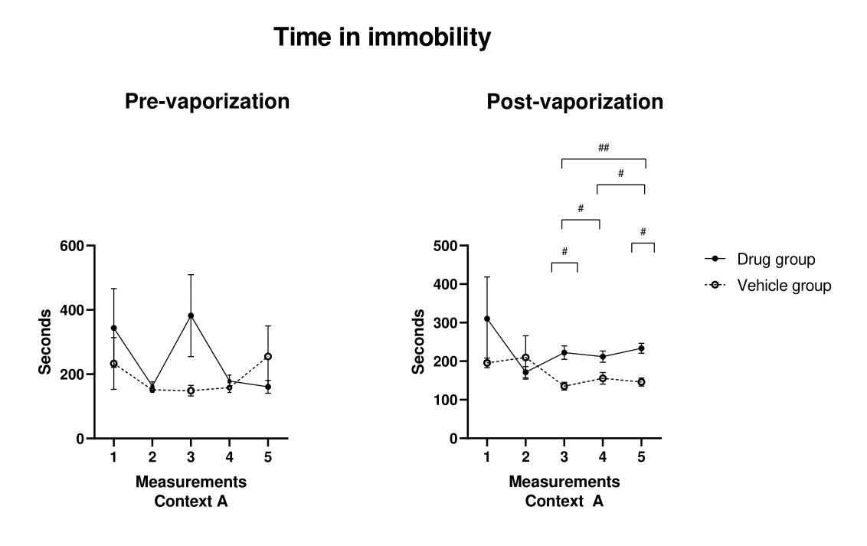
Note. Shown are the seconds in immobility of both groups for all pre-vaporization (left) and post-vaporization (right) chronic tolerance measurements in Context A (i.e., where the Drug group received cannabis). The bars represent the standard error of the mean. # indicates between-group differences between the Drug and Vehicle groups. The number of symbols reflects the level of statistical significance (e.g., #p < .05, ##p < .01, ###p < .001).
Post-hoc analyses were performed to evaluate differences between groups and measurements. During pre-vaporization no significant differences were found (all p-values > .05). On the other hand, during post-vaporization, differences were found between measurement 3 of the Drug group and measurement 3 of the Vehicle group (p = .018, MD = 87.432, SE = 20.404), measurement 3 of the Drug group and measurement 5 of the Vehicle group (p = .025, MD = 76.387, SE = 18.591), measurement 3 of the Vehicle group and measurement 4 of the Drug group (p = .050, MD = -76.787, SE = 20.694), measurement 3 of the Vehicle group and measurement 5 of the Drug group (p = .003, MD = -98.490, SE = 18. 591), measurement 4 of the Vehicle group and measurement 5 of the Drug group (p = .024, MD = -78.078, SE = 18.909) and measurement 5 of the Drug group and measurement 5 of the Vehicle group (p = .003, MD = 87.445, 16.581). Additionally, the comparison between the Drug group and the Vehicle group was also significant (p = .021, MD = 61.511, SE = 23.707).
Figure S6
Timeline of the experimental protocol
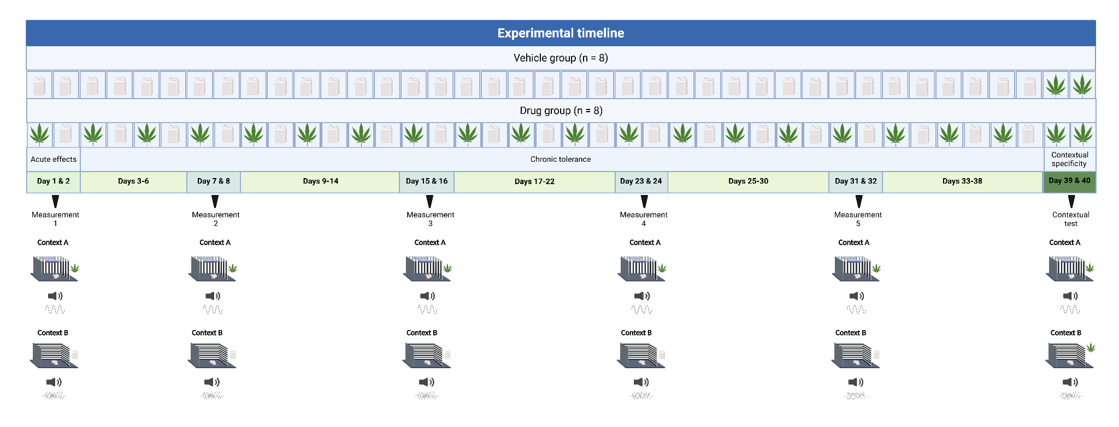
Note. The figure illustrates the experimental timeline of the study. The cannabis leaf represents vaporized cannabis administration, whereas the white container indicates vaporized propylene glycol administration. Black arrows denote the days on which behavioral measurements were conducted. Acute effects, chronic tolerance, and contextual specificity refer to the distinct experimental phases. At the bottom, the Drug group is used to exemplify contextual differentiation, with Context A corresponding to cannabis administration and Context B to vehicle administration—except during the contextual specificity phase. Created in https://BioRender.com
Figure S7
Pre- and post-vaporization scores in the usual and novel contexts during the contextual specificity test
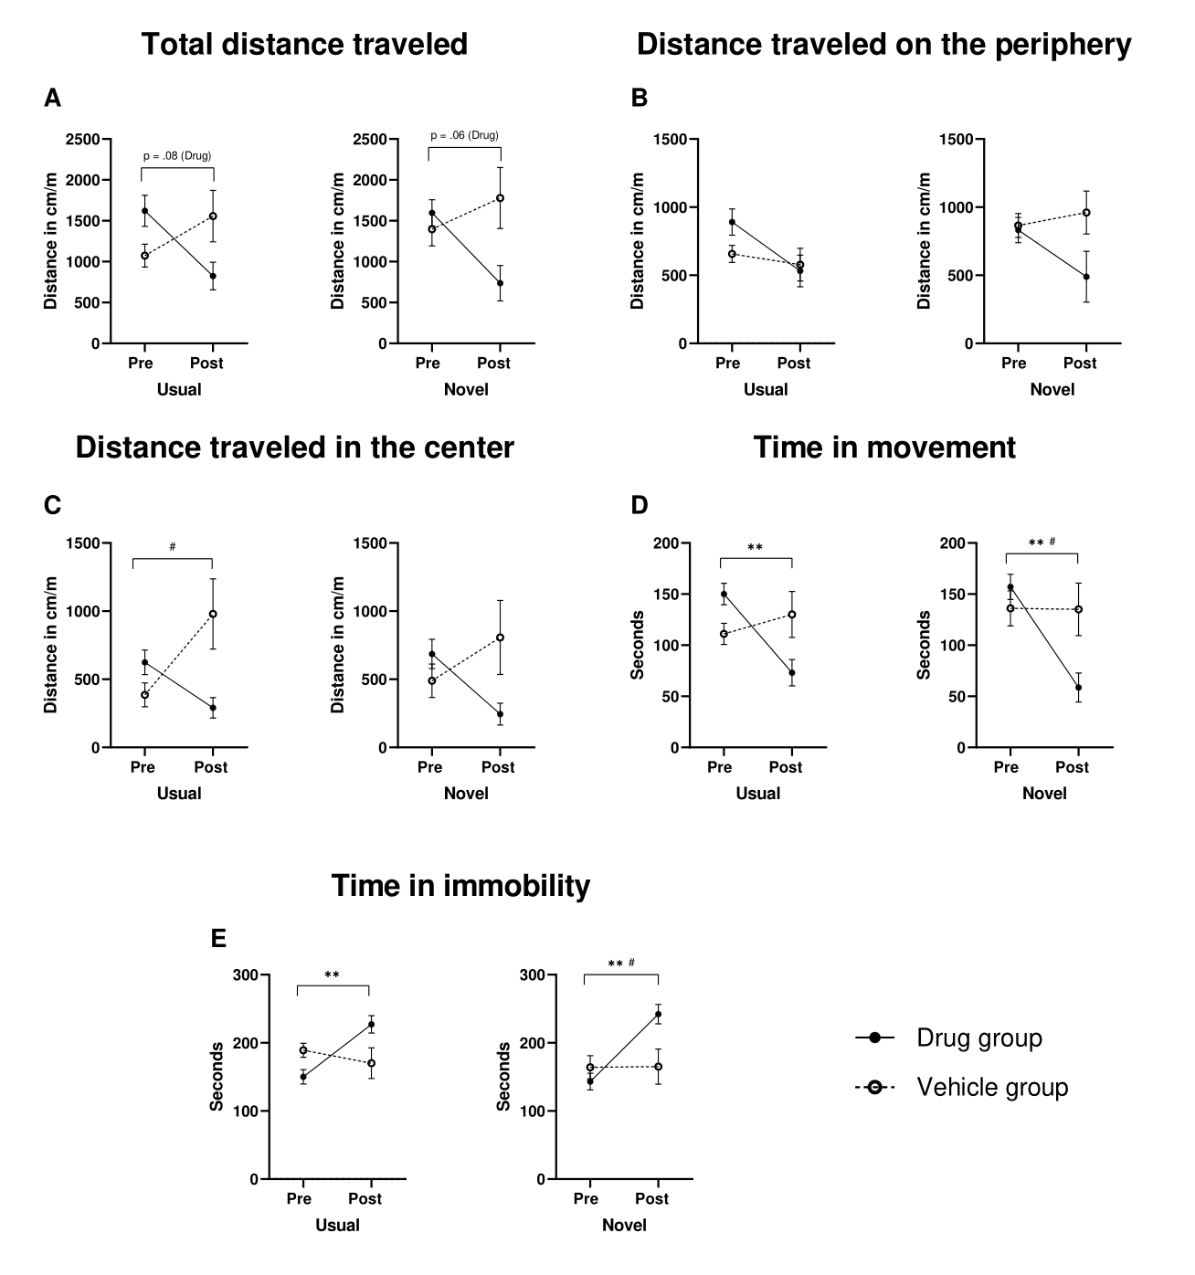
Note. Raw data from the context specificity test are presented for the indices that previously showed evidence of chronic tolerance. Both groups received cannabis administration (the first administration being for the Vehicle group), either in the Usual context (i.e., where the Drug group had previously received the drug) and in the Novel context (i.e., where the Drug group had never received the drug). A) Scores on the total distance traveled index. B) Scores on the distance traveled on the sides index. C) Scores on distance traveled in the center index. D) Scores on the movement time index. E) Scores on the immobility time index. The bars represent the standard error of the mean.
Post-hoc analyses were conducted to evaluate group differences in the usual and novel contexts during the context specificity test. For the variable Total distance traveled, a trend toward significance was observed in the Drug group between pre- and post-vaporization scores, both in the Usual context (p = .082, MD = 798, SE = 303) and in the Novel context (p = .066, MD = 860, SE = 313). For Distance traveled in the center, a significant difference was found between pre- and post-vaporization scores in the Drug group in the Usual context (p = .039, MD = –594.1, SE = 195). Regarding Time in movement, significant differences were found in the Drug group between pre- and post-vaporization scores in both the Usual context (p = .009, MD = 77.1, SE = 20.2) and the Novel context (p = .008, MD = 98.55, SE = 25.5). Additionally, a significant difference was observed between the pre-vaporization score of the Vehicle group and the post-vaporization score of the Drug group in the Novel context (p = .039, MD = 78, SE = 25.7). Similarly, for Time in immobility, significant pre–post differences were observed in the Drug group in both the Usual context (p = .009, MD = –77.1, SE = 20.2) and the novel context (p = .008, MD = –98.55, SE = 25.5). A significant difference was also found between the Vehicle group’s pre-vaporization score and the Drug group’s post-vaporization score in the Novel context (p = .039, MD = –78, SE = 25.7). No significant differences were observed for Distance traveled on the periphery or Distance traveled in the center (all p-values > .05).

References
Rouder, J. N., Speckman, P. L., Sun, D., Morey, R. D., & Iverson, G. (2009). Bayesian t tests for accepting and rejecting the null hypothesis. Psychonomic Bulletin & Review, 16, 225-237. https://doi.org/10.3758/PBR.16.2.225
The jamovi project (2022). jamovi (Version 2.3) [Computer Software]. Retrieved from https://www.jamovi.org.

